

IMPLEMENTATION PROCESS

**Version1.0**

**Quốc Nhân**

**07/11/2019**

**VERSION HISTORY**

|  |  |  |  |  |  |
| --- | --- | --- | --- | --- | --- |
| **Version #** | **Implemented**  **By** | **Revision**  **Date** | **Approved**  **By** | **Approval**  **Date** | **Reason** |
| 1.0 | Quốc Nhân | 07/11/2019 |  |  | Create Document Implement process version 1.0 |
|  |  |  |  |  |  |
|  |  |  |  |  |  |
|  |  |  |  |  |  |

Table of Contents

1. Introduction 3

1.1 Objective and Scope 3

1.2 Intended Audiences 3

1. Implement process 3

2.1 Process 3

2.2 Description 3

2.3 Role and Responsibility 3

2.4 Template for Apply Process 3

2.5 Tools 3

**List of Table**

table : 1 Intended audiences 3

table : 2 Description 3

table : 3 Role and responsibility 3

table : 4 Template for apply 3

table : 5 tools 3

FIGURE: 1 Implement process activity 3

# 

# Introduction

## Objective and scope

## **Intended audiences**

# Implement process

## Process

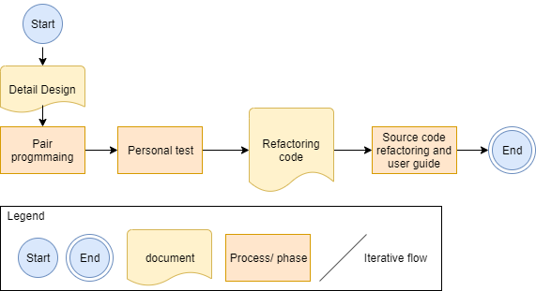

Figure 1: Implement Process Activity

## **Description**

|  |  |  |  |
| --- | --- | --- | --- |
| **Stage** | **Input** | **Output** | **Describe** |
| Pair Programming | SRS document  Detail design document | Source code | * Programmers will conduct code and fix bugs. All of programmer working together, * All of programmers should swap their roles frequently |
| Personal Test | Source code | System built  Standard output document | * The programmer will run all tests to build the system |
| Source code refactoring user guide | Source code | Source code refactoring  Use Guide document | * Programmers in this phase complete the structural improvements to optimize the code to make the software work better, reducing errors. |

## Role and responsibility

|  |  |  |
| --- | --- | --- |
| **Id** | **Roles** | **Responsibility** |
| 1 | Project Manager | Main responsibility for the schedule and overall success of the project |
| 2 | Code Leader | Lead, plan and track the progress of the coding team. Report directly to the project manager. |
| 3 | Programmer | Write source code, unit code for the system, fix bug from the tester.  Direct reporting Coding leader when problems with coding. |
| 4 | Support | Training code for all team member |

Table 3: Role and Responsibility

## **Template for apply process**

|  |  |  |  |
| --- | --- | --- | --- |
| **No** | **Template** | **Description** | **Location** |
| 1 | Software Requirement Specification (SRS) | The content of the document represents the overall "App real estate" system, problems, solutions, technical specifications and functionality. From a technical perspective. | Process\Requirement |
| 2 | Detail Design Document | Document describing additional work requirements for the Design section. | Process\Design Management |

Table 4: Template for apply

## Tools

|  |  |  |
| --- | --- | --- |
| **Id** | **Description** | **Configuration** |
| 1 | Work environment | Microsoft Office Word  Microsoft Office Excel  Github |

Table 5: Tools